**PROJECT**



**APPLE CLONE**

**Done By:**

**AMAN VERMA**

**SUMMARY:**

1. **HTML (index.html)**:
   * The main structure of the website is defined here.
   * Includes a header with navigation links (e.g., Store, Mac, iPad, iPhone, etc.), a search icon, and a shopping bag icon.
   * Contains sections for:
     + A donation banner with an image.
     + Product showcases for iPhone 16 Pro, iPhone 16, and Apple Watch.
     + A grid layout for additional products like MacBook Air, iPad Pro, AirPods Pro, etc.
     + A slider showcasing promotional images.
     + A content section with detailed information and disclaimers.
     + A video element for an introductory video.
2. **CSS (stylesheet.css)**:
   * Provides styling for the website, focusing on a clean and modern design.
   * Implements responsive design using media queries for smaller screens.
   * Uses grid and flexbox layouts for structured and responsive sections.
   * Includes hover effects for buttons and animations for the slider.
3. **Assets (**[images](vscode-file://vscode-app/c:/Users/Dell/AppData/Local/Programs/Microsoft%20VS%20Code%20Insiders/resources/app/out/vs/code/electron-sandbox/workbench/workbench.html)**)**:
   * Contains images and a video used in the website, such as product images, promotional banners, and a favicon.
4. **Features**

* **Header Navigation**:
  + Sticky header with navigation links and icons for search and shopping.
* **Product Showcase**:
  + Highlighted sections for flagship products like iPhone 16 Pro and Apple Watch.
  + Buttons for "Learn More" and "Buy" with hover effects.
* **Image Slider**:
  + A continuously scrolling slider showcasing promotional images.
  + Pauses on hover.
* **Video Integration**:
  + An autoplaying video that hides after the first play using session storage.
* **Responsive Design**:
  + Adjusts layout and visibility of elements for smaller screens.

**5. Purpose**

The project is likely a practice or demonstration of front-end development skills, showcasing:

* HTML structure and semantic elements.
* CSS styling, animations, and responsive design.
* Integration of multimedia elements like images and videos.
* Use of modern web design techniques inspired by Apple's aesthetic.

This project is a visually appealing and functional website that mimics a professional product showcase.

**COLOR THEORY:**

This project primarily relies on **images** for visual appeal, with minimal use of colors to maintain a clean and modern design. Here's a brief overview:

1. **Neutral Backgrounds**:
   * rgba(245, 245, 247, 0.8) (Light Gray with Transparency) is used for sections like the header and donation banner to create a subtle, clean look.
2. **Text Colors**:
   * rgb(37, 35, 35) (Dark Gray) for navigation links and text.
   * white (rgb(255, 255, 255)) for text on dark backgrounds.
3. **Accent Colors**:
   * rgb(77, 77, 248) (Bright Blue) for buttons like "Learn More" and "Buy," drawing attention to call-to-action elements.
4. **Hover Effects**:
   * Buttons change to white or  rgb(77, 77, 248) on hover for interactivity.
5. **Images**:
   * The design heavily uses **high-quality images** for product showcases (e.g., iPhone, Watch, MacBook) and promotional sections, making visuals the primary focus.

This minimalist approach aligns with Apple's aesthetic, emphasizing products over decorative elements.

**TYPOGRAPHY:**

1. **Font Size**:
   * **Header Links**: font-size: 14px; - Small and clean for navigation links.
   * **Donation Section**: font-size: 18px; - Slightly larger to grab attention.
   * **Product Content**: font-size: 30px; - Large and bold for product titles and descriptions.
   * **Buttons**: font-size: 15px; - Readable and consistent for call-to-action elements.
2. **Font Weight**:
   * **Buttons**: font-weight: bold; or font-weight: 550; - Emphasizes clickable elements.
   * **Content Text**: Regular weight for readability.
3. **Text Alignment**:
   * **Centered**: Most sections use text-align: center; for a balanced and clean layout.
   * **Start Alignment**: Used in paragraphs (text-align: start;) for better readability in longer text blocks.
4. **Color**:
   * **Dark Gray ( rgb(37, 35, 35) or  rgb(41, 36, 36))**: Used for text on light backgrounds for high contrast.
   * **White ( rgb(255, 255, 255))**: Used for text on dark or image backgrounds for visibility.
5. **Responsiveness**:
   * Font sizes are adjusted for smaller screens (e.g., .iphone16pro-content { font-size: 10px; }) to ensure readability on mobile devices.

The typography is simple and functional, aligning with the minimalist design and focusing on readability and clarity.

1. **Header + Donation Section:**



* + **Sticky Header**: Positioned at the top using position: sticky; to remain visible during scrolling.
  + **Navigation Links**: Styled with text-decoration: none; and color: rgb(37, 35, 35); for a clean look.
  + **Donation Banner**: Includes a **centered image** and **text**, styled with **flexbox** for alignment.

1. **Product Showcase (iPhone 16 Pro, iPhone 16, Watch):**

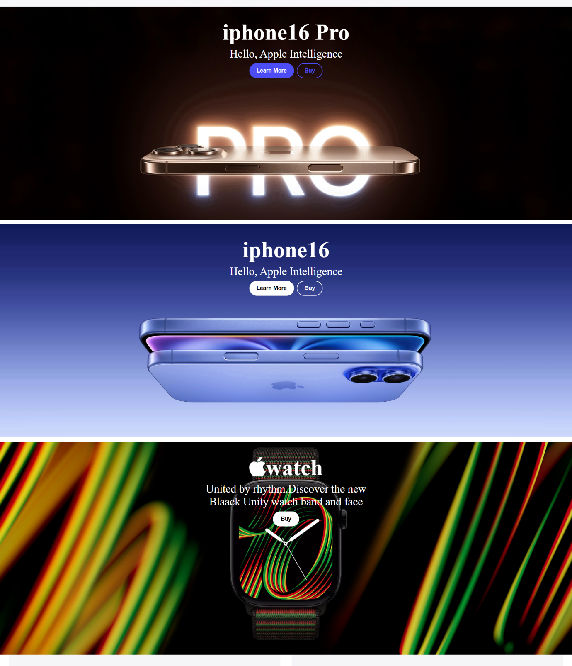

* + **Background Images**: High-quality images set using background-image for each product.
  + **Call-to-Action Buttons**: **"Learn More"** and **"Buy"** buttons with **hover effects** for interactivity.
  + **Flexbox Layout**: Ensures content is **centered** and **aligned properly**.

1. 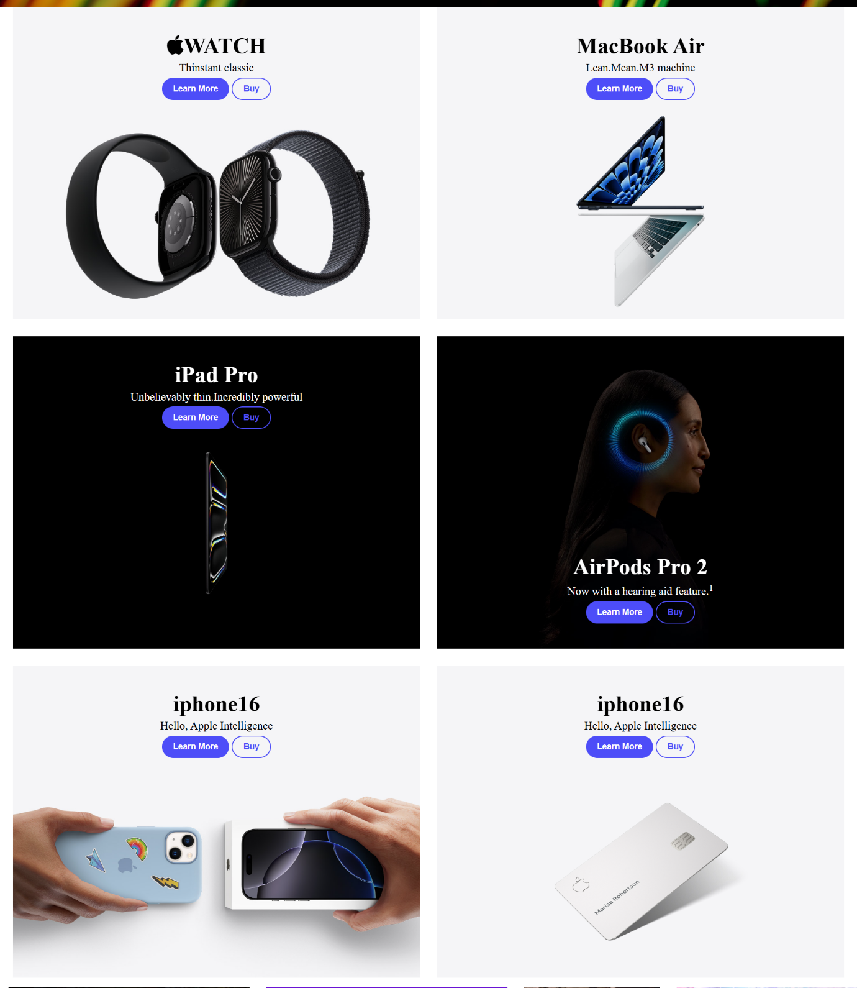**Grid Layout for Products:**
   * **Parent Grid**: A structured **grid layout** using grid-template-columns and grid-template-rows for showcasing multiple products.
   * **Responsive Design**: Adjusts to **single-column layout** on smaller screens using **media queries**.
2. 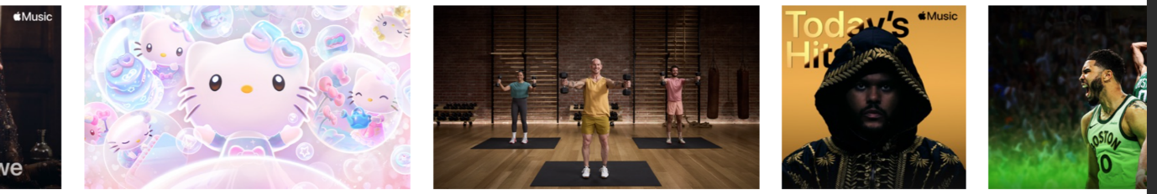**Image Slider:**
   * **Continuous Animation**: Uses @keyframes slide for **infinite horizontal scrolling**.
   * **Pause on Hover**: Animation pauses when the user hovers over the slider (animation-play-state: paused;).
3. **Content Section:**

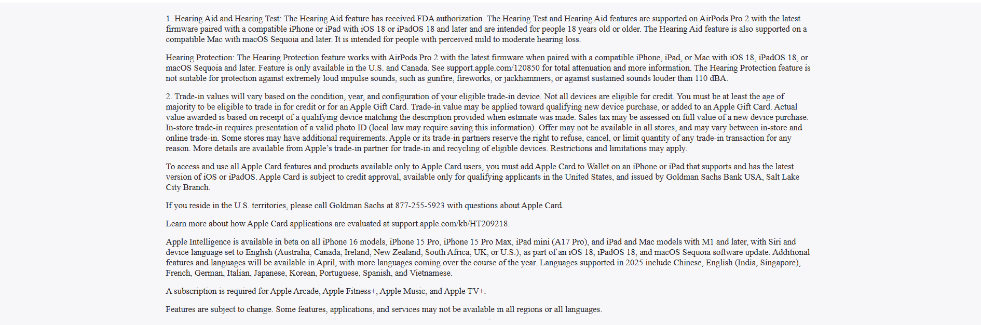

* + **Text-Based Information**: Includes **paragraphs** styled with text-align: start; and font-size: 13.5px; for readability.
  + **Background Styling**: Light background color (rgba(245, 245, 247, 0.8)) for contrast.

**MOBILE-RESPONSIVE**



1. **Header Adjustments:**
   * Navigation links are hidden on smaller screens using display: none;.
   * Logo alignment is adjusted with padding for better positioning.
2. **Product Section Resizing:**
   * Heights of sections like .iphone16pro, .iphone16, and .watch are reduced to 60vh for smaller screens.
   * Font sizes in product content are scaled down for readability.
3. **Grid Layout Adaptation:**
   * The .parent-box grid switches to a single-column layout (grid-template-columns: 1fr;) for mobile devices.
   * Row gaps are increased to 25px for better spacing.
4. **Slider Responsiveness:**
   * The slider remains functional on smaller screens, with overflow: hidden; ensuring it fits within the viewport**.**
5. **Content Section Adjustments:**
   * The .content section height is increased to 150vh and text width is adjusted to 85vw for better readability on narrow screens.

**HTML:**

<!DOCTYPE html>

<html lang="en">

<head>

    <meta charset="UTF-8">

    <meta name="viewport" content="width=device-width, initial-scale=1.0">

    <title>Apple</title>

    <link rel="stylesheet" href="stylesheet.css">

  <!-- font awesome cdn -->

    <link rel="stylesheet" href="https://cdnjs.cloudflare.com/ajax/libs/font-awesome/6.7.2/css/all.min.css"

        integrity="sha512-Evv84Mr4kqVGRNSgIGL/F/aIDqQb7xQ2vcrdIwxfjThSH8CSR7PBEakCr51Ck+w+/U6swU2Im1vVX0SVk9ABhg=="

        crossorigin="anonymous" referrerpolicy="no-referrer" />

    <link rel="icon" href="apple-favicon.avif">

</head>

<body>

    <header>

        <div class="header-logo">

            <i class="fa-brands fa-apple"></i>

        </div>

        <a href="">Store</a>

        <a href="">mac</a>

        <a href="">ipad</a>

        <a href="">iphone</a>

        <a href="">Watch</a>

        <a href="">Vision</a>

        <a href="">Airpod</a>

        <a href="">TV & Home</a>

        <a href="">Entertainment</a>

        <a href="">Accessories</a>

        <a href="">Support</a>

        <div class="header-search">

            <i class="fa-solid fa-magnifying-glass"></i>

        </div>

        <div class="header-bag">

<i class="fa-solid fa-bag-shopping"></i>

        </div>

        <div class="hamburger">

            <i class="fa-solid fa-bars"></i>

        </div>

    </header>

    <div class="donation">

        <div class="donation-img">

            <img src="Assest/images/header-hospital.jpg" alt="">

        </div>

        <a href="">Donate to 2025 Southern California wildfires</a>

    </div>

    <div class="grid-1">

        <div class="parent">

            <div class="iphone16pro">

                <div class="iphone16pro-content">

                    <h1>iphone16 Pro</h1>

                    <p>Hello, Apple Intelligence</p>

                    <div class="iphone16pro-content-button">

                        <a href=""><button class="learn-more">

                                Learn More

                            </button></a>

                        <a href="">

                            <button class="buy">Buy</button>

                        </a>

                    </div>

                </div>

            </div>

            <div class="iphone16">

                <div class="iphone16-content">

                    <h1>iphone16</h1>

                    <p>Hello, Apple Intelligence</p>

                    <div class="iphone16-content-button">

                        <a href=""><button class="learn-more">

                                Learn More

                            </button></a>

                        <a href="">

                            <button class="buy">Buy</button>

                        </a>

                    </div>

                </div>

            </div>

            <div class="watch">

                <div class="watch-content">

                    <h1><i class="fa-brands fa-apple"></i>watch</h1>

                    <p>United by rhythm.Discover the new Blaack Unity watch band and face</p>

                    <div class="watch-content-button">

                        <a href="">

                            <button class="buy">Buy</button>

                        </a>

                    </div>

                </div>

            </div>

        </div>

    </div>

    <div class="grid-2">

        <div class="parent-box">

            <div class="box1">

                <div class="box1-content">

                    <h1><i class="fa-brands fa-apple"></i>WATCH</h1>

                    <p>Thinstant classic</p>

                    <div class="box1-content-button">

                        <a href=""><button class="learn-more">

                                Learn More

                            </button></a>

                        <a href="">

                            <button class="buy">Buy</button>

                        </a>

                    </div>

                </div>

            </div>

            <div class="box2">

  <div class="box2-content">

                    <h1>MacBook Air</h1>

                    <p>Lean.Mean.M3 machine</p>

                    <div class="box2-content-button">

                        <a href=""><button class="learn-more">

                                Learn More

                            </button></a>

                        <a href="">

                            <button class="buy">Buy</button>

                        </a>

                    </div>

                </div>

            </div>

            <div class="box3">

                <div class="box3-content">

                    <h1>iPad Pro</h1>

                    <p>Unbelievably thin.Incredibly powerful</p>

                    <div class="box3-content-button">

                        <a href=""><button class="learn-more">

                                Learn More

                            </button></a>

                        <a href="">

                            <button class="buy">Buy</button>

                        </a>

                    </div>

                </div>

            </div>

            <div class="box4">

                <div class="box4-content">

                    <h1>AirPods Pro 2</h1>

                    <p>Now with a hearing aid feature.<sup>1</sup></p>

                    <div class="box4-content-button">

                        <a href=""><button class="learn-more">

                                Learn More

                            </button></a>

                        <a href="">

                            <button class="buy">Buy</button>

                        </a>

                    </div>

                </div>

            </div>

            <div class="box5">

                <div class="box5-content">

                    <h1>iphone16</h1>

                    <p>Hello, Apple Intelligence</p>

                    <div class="box5-content-button">

                        <a href=""><button class="learn-more">

                                Learn More

                            </button></a>

                        <a href="">

                            <button class="buy">Buy</button>

                        </a>

                    </div>

                </div>

            </div>

            <div class="box6">

                <div class="box6-content">

                    <h1>iphone16</h1>

                    <p>Hello, Apple Intelligence</p>

                    <div class="box6-content-button">

                        <a href=""><button class="learn-more">

                                Learn More

                            </button></a>

                        <a href="">

                            <button class="buy">Buy</button>

                        </a>

                    </div>

                </div>

            </div>

        </div>

    </div>

    <div class="slider-wrapper">

        <div class="slider">

            <img src="Assest/images/slider-1.jpg" alt="" class="slider-img">

            <img src="Assest/images/slider-2.jpg" alt="" class="slider-img">

            <img src="Assest/images/slider-3.jpg" alt="" class="slider-img">

            <img src="Assest/images/slider-4.jpg" alt="" class="slider-img">

            <img src="Assest/images/slider-5.jpg" alt="" class="slider-img">

            <img src="Assest/images/slider-6.jpg" alt="" class="slider-img">

            <img src="Assest/images/slider-1.jpg" alt="" class="slider-img">

            <img src="Assest/images/slider-2.jpg" alt="" class="slider-img">

            <img src="Assest/images/slider-3.jpg" alt="" class="slider-img">

            <img src="Assest/images/slider-4.jpg" alt="" class="slider-img">

            <img src="Assest/images/slider-5.jpg" alt="" class="slider-img">

            <img src="Assest/images/slider-6.jpg" alt="" class="slider-img">

        </div>

    </div>

    <div class="content">

        <p>1. Hearing Aid and Hearing Test: The Hearing Aid feature has received FDA authorization. The Hearing Test and

            Hearing Aid features are supported on AirPods Pro 2 with the latest firmware paired with a compatible iPhone

            or iPad with iOS 18 or iPadOS 18 and later and are intended for people 18 years old or older. The Hearing

            Aid feature is also supported on a compatible Mac with macOS Sequoia and later. It is intended for people

            with perceived mild to moderate hearing loss.</p>

        <p>Hearing Protection: The Hearing Protection feature works with AirPods Pro 2 with the latest firmware when

            paired with a compatible iPhone, iPad, or Mac with iOS 18, iPadOS 18, or macOS Sequoia and later. Feature is

            only available in the U.S. and Canada. See support.apple.com/120850 for total attenuation and more

            information. The Hearing Protection feature is not suitable for protection against extremely loud impulse

            sounds, such as gunfire, fireworks, or jackhammers, or against sustained sounds louder than 110 dBA.</p>

        <p>2. Trade‑in values will vary based on the condition, year, and configuration of your eligible trade‑in

            device. Not all devices are eligible for credit. You must be at least the age of majority to be eligible to

            trade in for credit or for an Apple Gift Card. Trade‑in value may be applied toward qualifying new device

            purchase, or added to an Apple Gift Card. Actual value awarded is based on receipt of a qualifying device

            matching the description provided when estimate was made. Sales tax may be assessed on full value of a new

            device purchase. In‑store trade‑in requires presentation of a valid photo ID (local law may require saving

            this information). Offer may not be available in all stores, and may vary between in‑store and online

            trade‑in. Some stores may have additional requirements. Apple or its trade‑in partners reserve the right to

            refuse, cancel, or limit quantity of any trade‑in transaction for any reason. More details are available

            from Apple’s trade-in partner for trade‑in and recycling of eligible devices. Restrictions and limitations

            may apply.</p>

        <p>To access and use all Apple Card features and products available only to Apple Card users, you must add Apple

            Card to Wallet on an iPhone or iPad that supports and has the latest version of iOS or iPadOS. Apple Card is

            subject to credit approval, available only for qualifying applicants in the United States, and issued by

            Goldman Sachs Bank USA, Salt Lake City Branch.</p>

        <p>If you reside in the U.S. territories, please call Goldman Sachs at 877-255-5923 with questions about Apple

            Card.</p>

        <p>Learn more about how Apple Card applications are evaluated at support.apple.com/kb/HT209218.</p>

        <p>Apple Intelligence is available in beta on all iPhone 16 models, iPhone 15 Pro, iPhone 15 Pro Max, iPad mini

            (A17 Pro), and iPad and Mac models with M1 and later, with Siri and device language set to English

            (Australia, Canada, Ireland, New Zealand, South Africa, UK, or U.S.), as part of an iOS 18, iPadOS 18, and

            macOS Sequoia software update. Additional features and languages will be available in April, with more

            languages coming over the course of the year. Languages supported in 2025 include Chinese, English (India,

            Singapore), French, German, Italian, Japanese, Korean, Portuguese, Spanish, and Vietnamese.</p>

        <p>A subscription is required for Apple Arcade, Apple Fitness+, Apple Music, and Apple TV+.</p>

        <p>Features are subject to change. Some features, applications, and services may not be available in all regions

            or all languages.

        </p>

        <hr>

    </div>

    <video id="introVideo" width="100%" autoplay muted playsinline>

        <source src="Assest/images/vid.mp4" type="video/mp4">

        Your browser does not support the video tag.

    </video>

</body>

</html>

**CSS:**

*{

    margin: 0;

    padding: 0;

    box-sizing: border-box;

}

header{

    height: 45px;

    background-color: rgba(245, 245, 247, .8);

    /* background-color: transparent; */

    display: flex;

    align-items: center;

    justify-content: center;

    column-gap: 35px;

    position: sticky;

    top: 0;

    z-index: 100;

}

header a{

    text-decoration: none;

    color: rgb(37, 35, 35);

    font-size: 14px;

}

.hamburger{

    display: none;

}

.donation{

    display: flex;

    align-items: center;

    justify-content: center;

    height: 90px;

    background-color: rgba(245, 245, 247, .8);

    font-size: 18px;

}

.donation .donation-img img{

    width: 45px;

}

.parent {

    height: 250vh;

    display: grid;

    grid-template-columns: 1fr;

    grid-template-rows: repeat(3, 1fr);

    grid-column-gap: 30px;

    grid-row-gap: 12px;

    }

 .iphone16pro { grid-area: 1 / 1 / 2 / 2; }

    .iphone16 { grid-area: 2 / 1 / 3 / 2; }

    .watch { grid-area: 3 / 1 / 4 / 2; }

.iphone16pro{

    width: 100%;

background-image: url(Assest/images/xyz.PNG);

    background-repeat: no-repeat;

    background-size: cover;

    background-position: center;

    display: flex;

    justify-content: center;

    align-items: start;

}

.iphone16pro .iphone16pro-content{

    padding-top: 5vh;

    display: flex;

    align-items: center;

    justify-content: center;

    flex-direction: column;

    color: white;

    font-size: 30px;

    row-gap: 6px;

}

.iphone16pro .iphone16pro-content .learn-more{

    width: 120px;

    height: 40px;

    background-color: rgb(77, 77, 248);

    color: white;

    border-radius: 20px;

    font-weight: bold;

    border: none;

    font-size: 15px;

}

.iphone16pro .iphone16pro-content .buy{

    width: 70px;

    height: 40px;

    border: 2px solid rgb(77, 77, 248);

    border-radius: 20px;

    background-color: transparent;

    font-weight: 550;

    font-size: 15px;

    color: rgb(77, 77, 248);

}

.iphone16pro .iphone16pro-content .buy:hover{

    background-color: rgb(77, 77, 248);

    color: white;

}

/* iphone 16 */

.iphone16{

    /* height: 585px;

    width: 100%; */

    background-image: url(Assest/images/iphone16-blue1.JPG);

    background-repeat: no-repeat;

    background-size: cover;

    background-position: center;

    display: flex;

    justify-content: center;

    align-items: start;

}

.iphone16 .iphone16-content{

    padding-top: 5vh;

    display: flex;

    align-items: center;

    justify-content: center;

    flex-direction: column;

    color: white;

    font-size: 30px;

    row-gap: 6px;

    /* scroll-snap-type: ; */

}

.iphone16 .iphone16-content .learn-more{

    width: 120px;

    height: 40px;

    background-color: rgb(255, 255, 255);

    color: black;

    border-radius: 20px;

    font-weight: bold;

    border: none;

    font-size: 15px;

}

.iphone16 .iphone16-content .buy{

    width: 70px;

    height: 40px;

    border: 2px solid white;

    border-radius: 20px;

    background-color: transparent;

    font-weight: 550;

    font-size: 15px;

    color: white;

}

.iphone16 .iphone16-content .buy:hover{

    background-color: white;

    color: black;

}

/* WATCH CONTAINER */

.watch{

    /* height: 585px; */

    background-image: url(Assest/images/watch.jpg);

    background-repeat: no-repeat;

    background-size: cover;

    background-position: bottom center;

    display: flex;

    justify-content: center;

    align-items: start;

    /* background-color: rgb(67, 102, 255); */

    animation: scroll linear;

    animation-timeline: view();

    animation-range: entry cover 40%;

}

.watch .watch-content{

    padding-top: 5vh;

    width: 500px;

    text-align: center;

    display: flex;

    align-items: center;

    justify-content: center;

    flex-direction: column;

    color: white;

    font-size: 30px;

    row-gap: 6px;

}

.watch .watch-content-button .buy{

    width: 70px;

    height: 40px;

    border: 2px solid white;

    border-radius: 20px;

    background-color: white;

    font-weight: 550;

    font-size: 15px;

    color: black;

}

.wacth .watch-content .buy:hover{

    background-color: white;

    color: black;

}

/*

@keyframes scroll {

    from{

        opacity: 0;

        scale:0.5;

    }

    to{

        opacity: 1;

        scale:1;

    }

} */

/*

.watch-mac{

    margin-top: 15px;

    display: flex;

    justify-content: space-around;

    align-items: center;

} */

.grid-2{

    display: flex;

    justify-content: center;

    align-items: center;

}

.parent-box {

    height: 250vh;

    width: 97%;

    display: grid;

    grid-template-columns: repeat(2, 1fr);

    grid-template-rows: repeat(3, 1fr);

    grid-column-gap: 30px;

    grid-row-gap: 30px;

    }

    .box1 { grid-area: 1 / 1 / 2 / 2; }

    .box2 { grid-area: 1 / 2 / 2 / 3; }

    .box3 { grid-area: 2 / 1 / 3 / 2; }

    .box4 { grid-area: 2 / 2 / 3 / 3; }

    .box5 { grid-area: 3 / 1 / 4 / 2; }

    .box6 { grid-area: 3 / 2 / 4 / 3; }

.box1{

    /* height: 595px;

    width: 720px; */

    background-image: url(Assest/images/promo-watch.jpg);

    background-repeat: no-repeat;

    background-size: cover;

    background-position: center;

    display: flex;

    justify-content: center;

    align-items: start;

    animation: scroll linear;

    animation-timeline: view();

    animation-range: entry cover 40%;

    /* animation-range: exit ; */

    /* background-color: rgb(67, 102, 255); */

}

.box1 .box1-content{

    padding-top: 45px;

    display: flex;

    align-items: center;

    justify-content: center;

    flex-direction: column;

    color: black;

    font-size: 20px;

    row-gap: 6px;

}

.box1 .box1-content .learn-more{

    width: 120px;

    height: 40px;

    background-color: rgb(77, 77, 248);

    color: white;

    border-radius: 20px;

    font-weight: bold;

    border: none;

    font-size: 15px;

}

.box1 .box1-content .buy{

    width: 70px;

    height: 40px;

    border: 2px solid rgb(77, 77, 248);

    border-radius: 20px;

    background-color: transparent;

    font-weight: 550;

    font-size: 15px;

    color: rgb(77, 77, 248);

}

.box1 .box1-content .buy:hover{

    background-color: rgb(77, 77, 248);

    color: white;

}

.box2{

    /* height: 590px;

    width: 720px; */

    background-image: url(Assest/images/lap.jpg);

    background-repeat: no-repeat;

    background-size: cover;

    background-position: center;

    display: flex;

    justify-content: center;

    align-items: start;

    animation: scroll linear;

    animation-timeline: view();

    animation-range: entry cover 40%;

    /* animation-range: exit ; */

    /* background-color: rgb(67, 102, 255); */

}

.box2 .box2-content{

    padding-top: 45px;

    display: flex;

    align-items: center;

    justify-content: center;

    flex-direction: column;

    color: black;

    font-size: 20px;

    row-gap: 6px;

}

.box2 .box2-content .learn-more{

    width: 120px;

    height: 40px;

    background-color: rgb(77, 77, 248);

    color: white;

    border-radius: 20px;

    font-weight: bold;

    border: none;

    font-size: 15px;

}

.box2 .box2-content .buy{

    width: 70px;

    height: 40px;

    border: 2px solid rgb(77, 77, 248);

    border-radius: 20px;

    background-color: transparent;

    font-weight: 550;

    font-size: 15px;

    color: rgb(77, 77, 248);

}

.box2 .box2-content .buy:hover{

    background-color: rgb(77, 77, 248);

    color: white;

}

.ipad-airpod{

    margin-top: 15px;

    display: flex;

    justify-content: space-around;

    align-items: center;

}

.box3{

    /* height: 595px;

    width: 720px; */

    background-image: url(Assest/images/box3.jpg);

    background-repeat: no-repeat;

    background-size: cover;

    background-position: center;

    display: flex;

    justify-content: center;

    align-items: start;

    animation: scroll linear;

    animation-timeline: view();

    animation-range: entry cover 40%;

    /* animation-range: exit ; */

    /* background-color: rgb(67, 102, 255); */

}

.box3 .box3-content{

    padding-top: 45px;

    display: flex;

    align-items: center;

    justify-content: center;

    flex-direction: column;

    color: white;

    font-size: 20px;

    row-gap: 6px;

}

.box3 .box3-content .learn-more{

    width: 120px;

    height: 40px;

    background-color: rgb(77, 77, 248);

    color: white;

    border-radius: 20px;

    font-weight: bold;

    border: none;

    font-size: 15px;

}

.box3 .box3-content .buy{

    width: 70px;

    height: 40px;

    border: 2px solid rgb(77, 77, 248);

    border-radius: 20px;

    background-color: transparent;

    font-weight: 550;

    font-size: 15px;

    color: rgb(77, 77, 248);

}

.box3 .box3-content .buy:hover{

    background-color: rgb(77, 77, 248);

    color: white;

}

.box4{

    /* height: 590px;

    width: 720px; */

    background-image: url(Assest/images/box4.jpg);

    background-repeat: no-repeat;

    background-size: cover;

    background-position: center;

    display: flex;

    justify-content: center;

    align-items: end;

    padding-bottom: 45px;

    animation: scroll linear;

    animation-timeline: view();

    animation-range: entry cover 40%;

    /* animation-range: exit ; */

    /* background-color: rgb(67, 102, 255); */

}

.box4 .box4-content{

    padding-top: 45px;

    display: flex;

    align-items: center;

    justify-content: center;

    flex-direction: column;

    color: white;

    font-size: 20px;

    row-gap: 6px;

}

.box4 .box4-content .learn-more{

    width: 120px;

    height: 40px;

    background-color: rgb(77, 77, 248);

    color: white;

    border-radius: 20px;

    font-weight: bold;

    border: none;

    font-size: 15px;

}

.box4 .box4-content .buy{

    width: 70px;

    height: 40px;

    border: 2px solid rgb(77, 77, 248);

    border-radius: 20px;

    background-color: transparent;

    font-weight: 550;

    font-size: 15px;

    color: rgb(77, 77, 248);

}

.box4 .box4-content .buy:hover{

    background-color: rgb(77, 77, 248);

    color: white;

}

/* xxxxxxxxxxxxxxxxxxxxxxxxxxxxxxxxxxxxxxxxxxxxxxxxx */

.trade-card{

    margin-top: 15px;

    display: flex;

    justify-content: space-around;

    align-items: center;

}

.box5{

    /* height: 595px;

    width: 720px; */

    background-image: url(Assest/images/box5.jpg);

    background-repeat: no-repeat;

    background-size: cover;

    background-position: center;

    display: flex;

    justify-content: center;

    align-items: start;

    animation: scroll linear;

    animation-timeline: view();

    animation-range: entry cover 40%;

    /* animation-range: exit ; */

    /* background-color: rgb(67, 102, 255); */

}

.box5 .box5-content{

    padding-top: 45px;

    display: flex;

    align-items: center;

    justify-content: center;

    flex-direction: column;

    color: black;

    font-size: 20px;

    row-gap: 6px;

}

.box5 .box5-content .learn-more{

    width: 120px;

    height: 40px;

    background-color: rgb(77, 77, 248);

    color: white;

    border-radius: 20px;

    font-weight: bold;

    border: none;

    font-size: 15px;

}

.box5 .box5-content .buy{

    width: 70px;

    height: 40px;

    border: 2px solid rgb(77, 77, 248);

    border-radius: 20px;

    background-color: transparent;

    font-weight: 550;

    font-size: 15px;

    color: rgb(77, 77, 248);

}

.box5 .box5-content .buy:hover{

    background-color: rgb(77, 77, 248);

    color: white;

}

.box6{

    /* height: 590px;

    width: 720px; */

    background-image: url(Assest/images/box6.jpg);

    background-repeat: no-repeat;

    background-size: cover;

    background-position: center;

    display: flex;

    justify-content: center;

    align-items: start;

    padding-bottom: 45px;

    animation: scroll linear;

    animation-timeline: view();

    animation-range: entry cover 40%;

    /* animation-range: exit ; */

    /* background-color: rgb(67, 102, 255); */

}

.box6 .box6-content{

    padding-top: 45px;

    display: flex;

    align-items: center;

    justify-content: center;

    flex-direction: column;

    color: black;

    font-size: 20px;

    row-gap: 6px;

}

.box6 .box6-content .learn-more{

    width: 120px;

    height: 40px;

    background-color: rgb(77, 77, 248);

    color: white;

    border-radius: 20px;

    font-weight: bold;

    border: none;

    font-size: 15px;

}

.box6 .box6-content .buy{

    width: 70px;

    height: 40px;

    border: 2px solid rgb(77, 77, 248);

    border-radius: 20px;

    background-color: transparent;

    font-weight: 550;

    font-size: 15px;

    color: rgb(77, 77, 248);

}

.box6 .box6-content .buy:hover{

    background-color: rgb(77, 77, 248);

    color: white;

}

.slider-wrapper {

    width: 100%;

    overflow: hidden;

    height: 40vh;

    display: flex;

    align-items: center;

}

.slider {

    width: max-content;

    display: flex;

    animation: slide 35s linear infinite;

}

.slider-img {

    padding: 0 15px;

    height: 35vh;

}

.slider:hover{

    animation-play-state: paused;

}

@keyframes slide {

    0% {

        transform: translateX(0);

    }

    100% {

        transform: translateX(-50%);

    }

}

/* .slider:hover{

    animation-duration: 40s;

} */

.content{

    height: 500px;

    display: flex;

    align-items: center;

    justify-content: center;

    flex-direction: column;

    background-color: rgba(245, 245, 247, .8);

    margin-top: 10px;

    /* animation: scroll;

    animation-timeline: view();

    animation-range: entry cover 40%; */

}

.content p{

    text-align: start;

    width: 65vw;

    font-size: 13.5px;

    color: rgb(41, 36, 36);

    padding: 6px 0;

}

@media screen and (width<=480px) {

    header a{

        display: none;

    }

    .header-logo{

        padding-right: 250px;

    }

    .parent{

        height: 190vh;

    }

    .iphone16pro{

        height: 60vh;

    }

    .iphone16pro-content{

        font-size: 10px;

    }

    .iphone16{

        height: 60vh;

    }

   .watch{

    height: 60vh;

   }

   .parent-box {

    padding: 10px 0;

    height: 550vh;

    display: grid;

    grid-template-columns: 1fr;

    grid-template-rows: repeat(6, 1fr);

    grid-column-gap: 0px;

    grid-row-gap: 25px;

    }

    .box1 { grid-area: 1 / 1 / 2 / 2; }

    .box2 { grid-area: 2 / 1 / 3 / 2; }

    .box3 { grid-area: 3 / 1 / 4 / 2; }

    .box4 { grid-area: 4 / 1 / 5 / 2; }

    .box5 { grid-area: 5 / 1 / 6 / 2; }

    .box6 { grid-area: 6 / 1 / 7 / 2; }

    .slider-wrapper{

    }

    .content{

        height: 150vh;

        width: 100%;

    }

    .content p{

        text-align: start;

        width: 85vw;

        font-size: 13.5px;

        color: rgb(41, 36, 36);

        padding: 6px 0;

    }

}

